**Capstone Project - The Battle of Neighborhoods**

*Anna Dudareva*

1. **Introduction**
   1. **Background**

Edmonton is the capital city of the [Canadian province](https://en.wikipedia.org/wiki/Provinces_and_territories_of_Canada) of [Alberta](https://en.wikipedia.org/wiki/Alberta). The current metro area population of Edmonton in 2020 is 1,461,000, a 2.17% increase from 2019, that makes it one of the most growing cities in the whole Canada. Moreover, Edmonton is a multinational city which arouses increased interest among investors. Having a part number of firms, technologies in various areas and industries located in and around Edmonton, this city attracts many people from different parts of Canada and rest of the world. Due to increasing population in the city, there is a large scope to set up businesses like shopping stores, hotels and hostels, restaurants, coffee shops, beauty and health shops, etc.

* 1. **Business problem**

The objective of this project is to analyze the neighbourhoods in Edmonton and divide them into different clusters based on the popular venues at each neighbourhood, by using data science methodology and machine learning techniques like clustering.

**1.3 Interest**

The target audience of this project is small business owners who want to set up their businesses like restaurants, coffee shops, beauty and health stores, etc. It would help them:

* to find out what kind venues already exist
* to find the optimal location based on the category of their business

1. **Data requirements**
   1. **Data source**

To achieve the project aim I will need the following data sets:

* A ready dataset with Borough name, Neighborhoods, Post Code and GPS coordinates of Alberta, Canada can be found on Wikipedia website: [https://en.wikipedia.org/wiki/List\_of\_postal\_codes\_of\_Canada:\_T](https://en.wikipedia.org/wiki/List_of_postal_codes_of_Canada:_T" \t "_blank). Furthermore, sorting information about neighborhoods only for Edmonton city

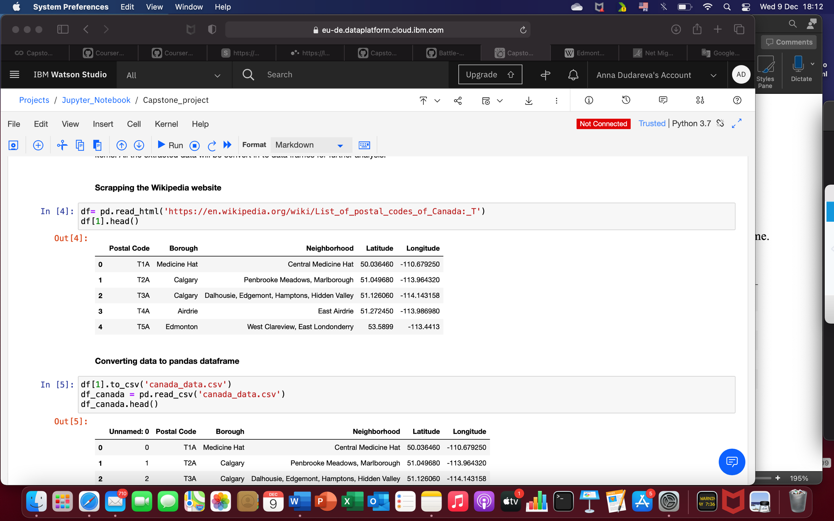

Image 1. Alberta neighborhoods dataset

* The Foursquare API was used to access the venues in the neighborhoods: [www.foursquare.com](http://www.foursquare.com)
* Then neighborhoods will be clustered based on their venues using Data Science Techniques, namely k-means algorithm, silhouette coefficient and plots
* Folium library can be used to visualize the clusters on the map of Edmonton

**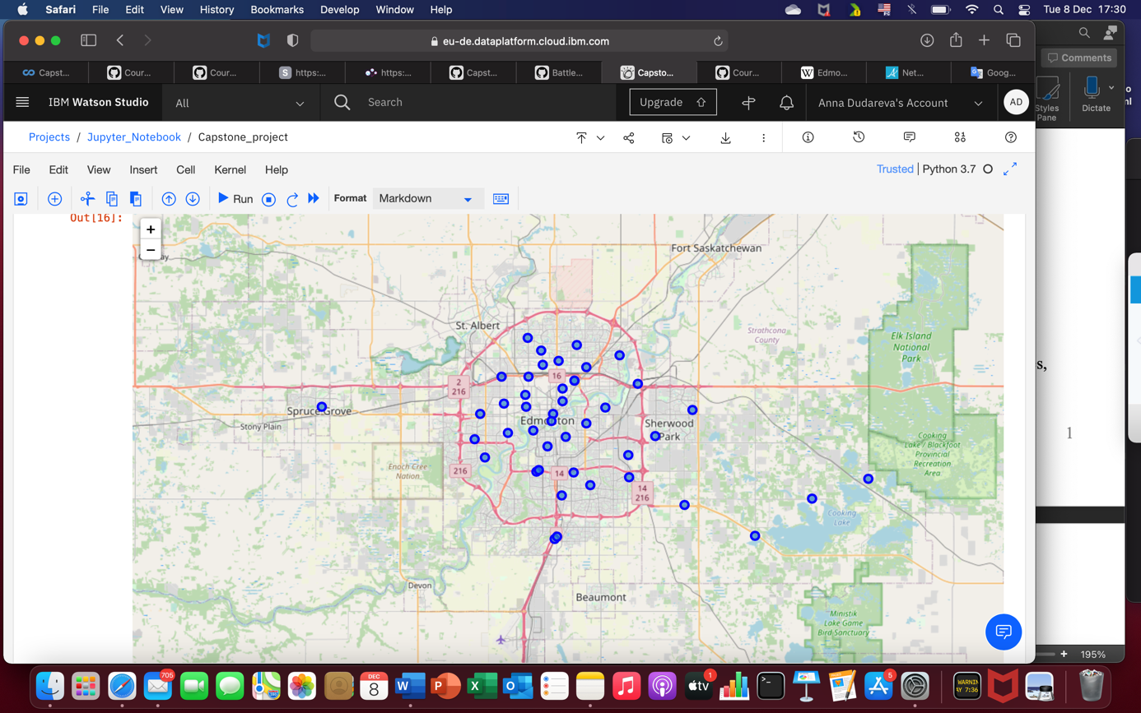**

Map 1. Edmonton city with neighborhoods

* 1. **Data cleaning**

Data cleaning and pre-processing involve scraping data of Alberta region and then of Edmonton city with all neighborhoods. Further, extracting directly neighborhoods of Edmonton and scraping venue items. All the extracted data was converted in to data frame for further analysis. There were a lot of missing values, so I decided to drop missing data.

In Image 1 you see the data from Foursquare API.

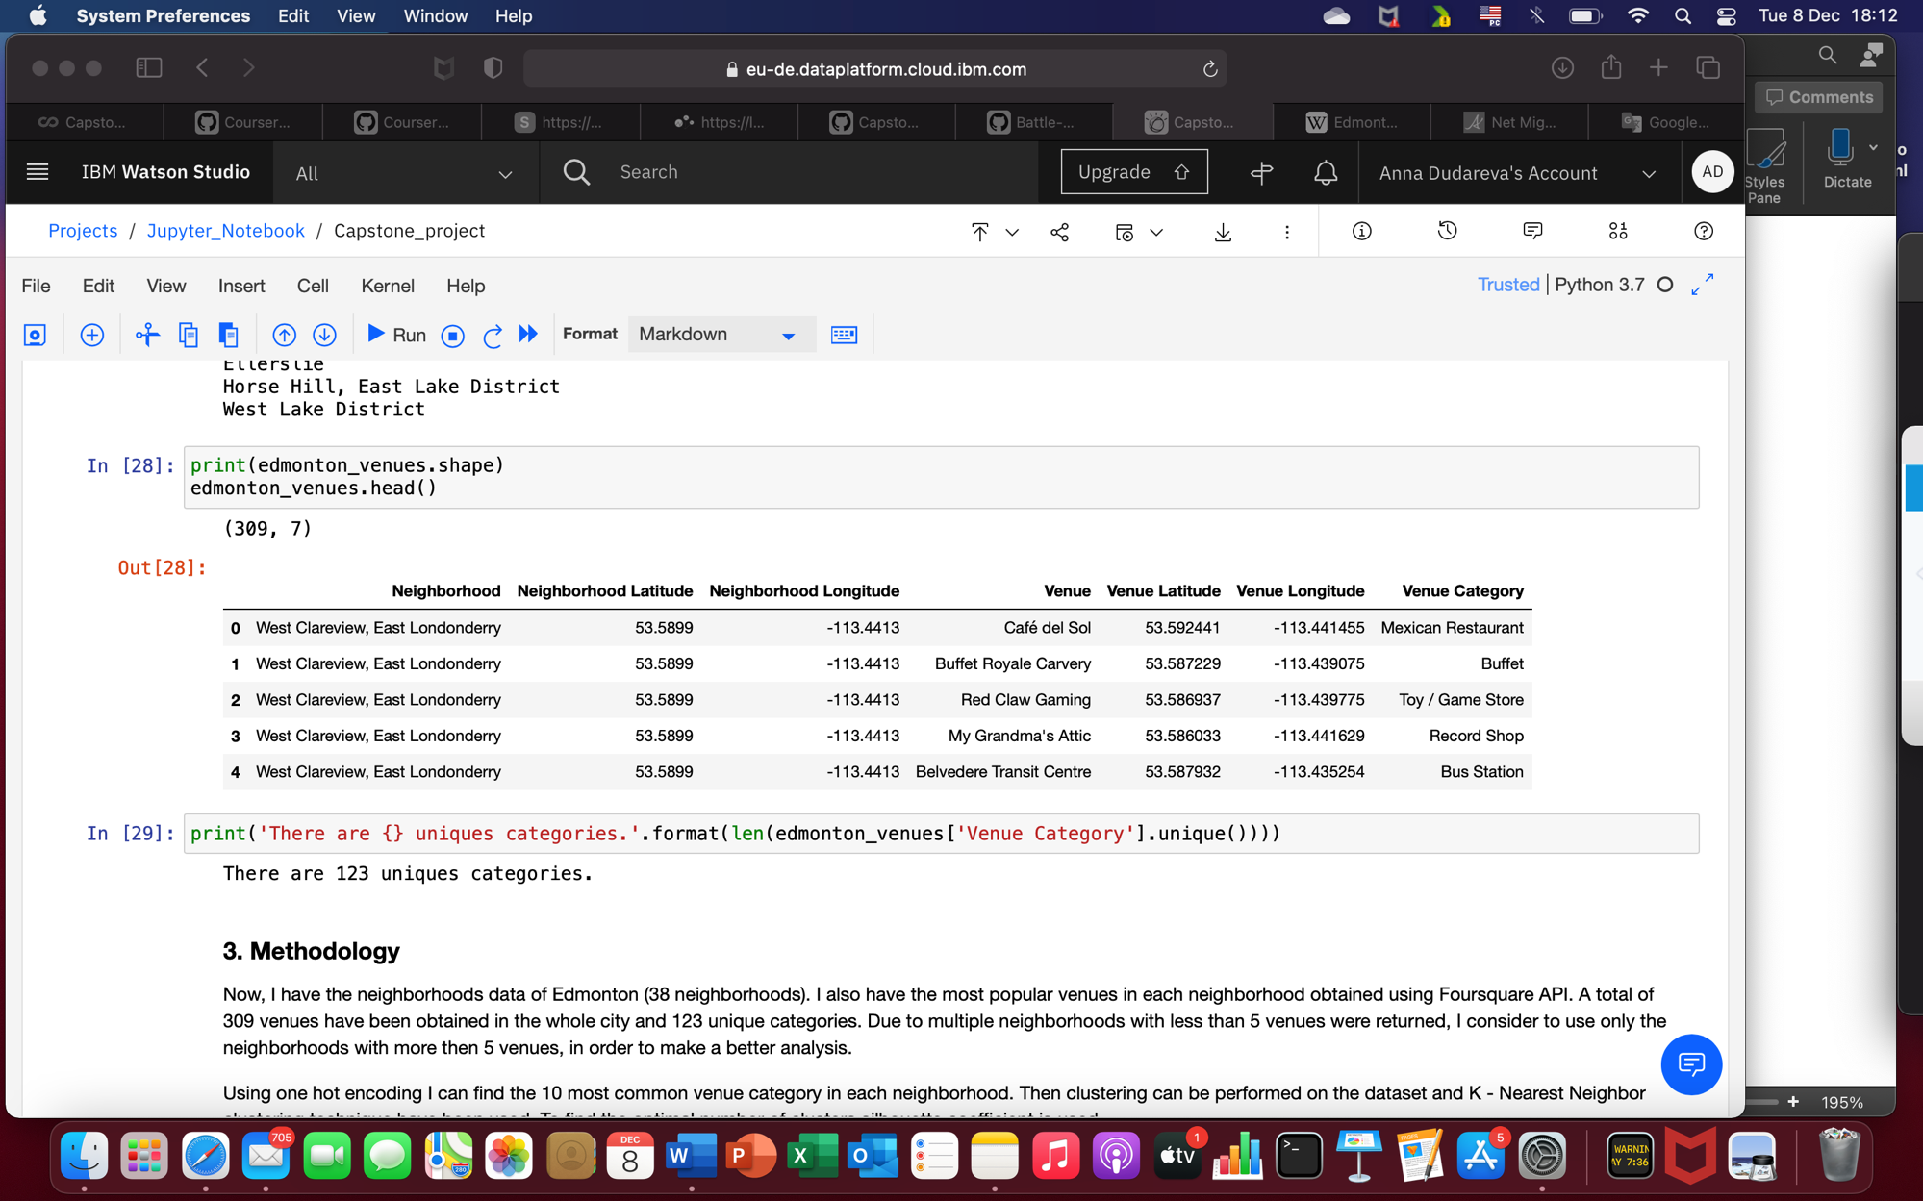

Image 2. Venues and venue categories in each neighborhood.

1. **Methodology**

I have the neighborhoods data of Edmonton, in total 38 neighborhoods. I also have the most popular venues in each neighborhood obtained using Foursquare API. A total of 309 venues have been obtained in the whole city and 123 unique categories.

Due to multiple neighborhoods with less than 5 venues were returned, I considered to use only the neighborhoods with more then 5 venues, in order to make a better analysis.

Using one hot encoding I can find the 10 most common venue category in each neighborhood. Then clustering can be performed on the dataset and K - Nearest Neighbor clustering technique have been used. To find the optimal number of clusters silhouette coefficient is used.

The clusters can be analyzed to find the major type of venue categories in each cluster. This data can be used to suggest business people suitable locations based on the category.

1. **Analysis**

4.1 As I mentioned in Methodology part, due to multiple neighborhoods with less than 5 venues, I decided to use only those which have more than 5 venues. Thereby, I have visualized those neighborhoods.

**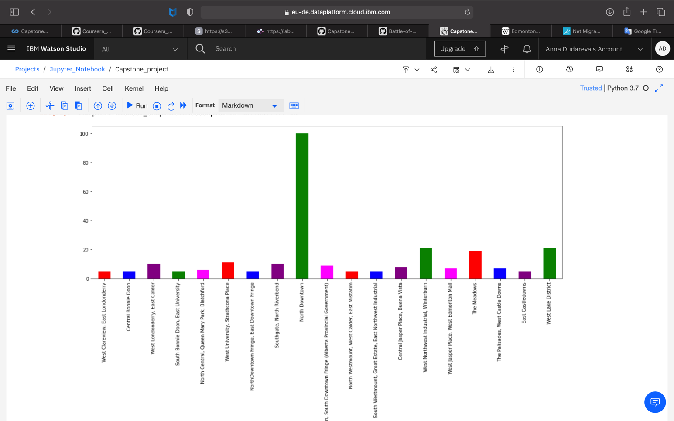**

Image 3. Neighborhoods with more than 5 venues

4.2 Next was one hot encoding on the filtered data to obtain the venue categories in each neighborhood. Then group the data by neighborhood and take the mean value of the frequency of occurrence of each category. The outcome is shown below.

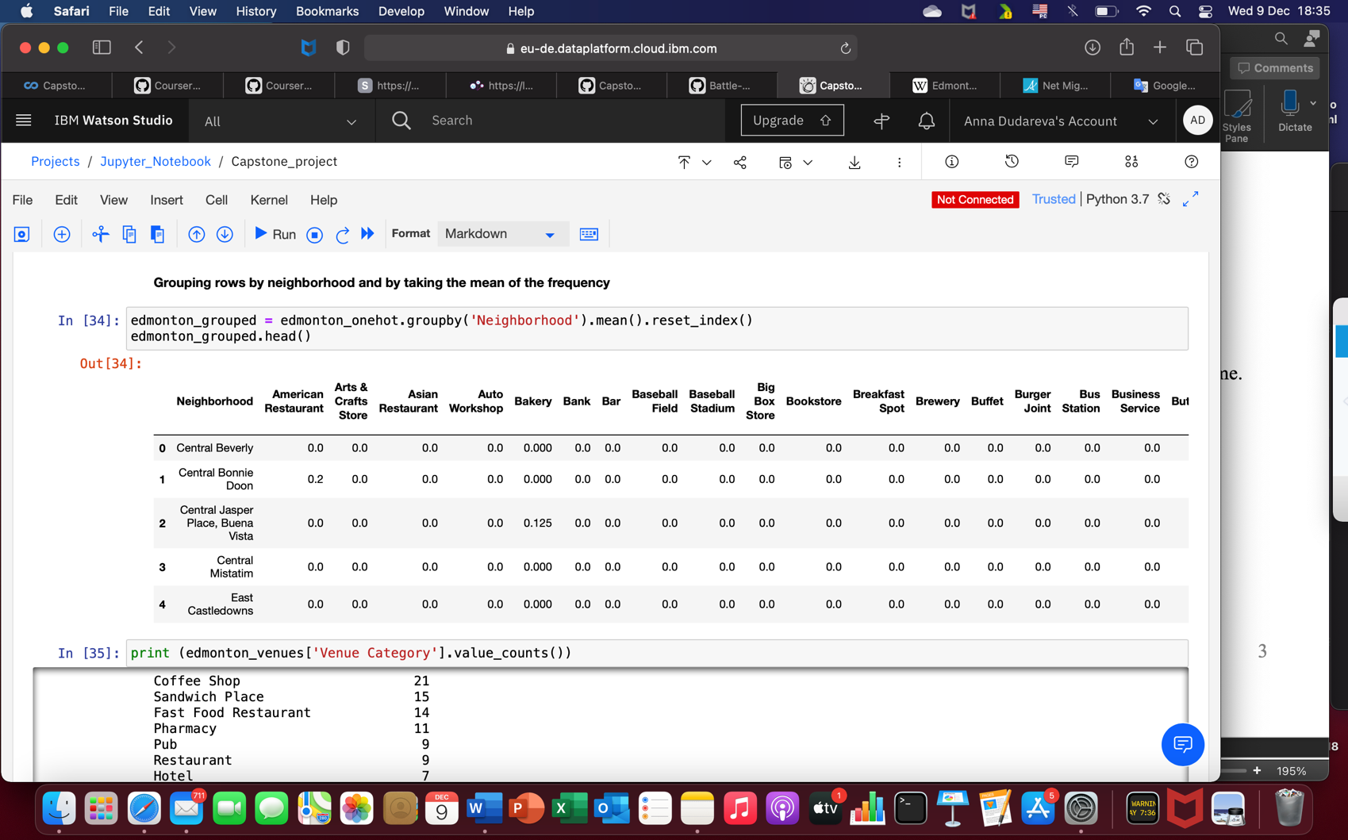

Image 3. Mean of frequency of occurrence of each category

4.3 One hot encoding was performed to obtain the 10 most common venues in each neighborhood, then stored these data in a new dataframe. A sample is shown below.

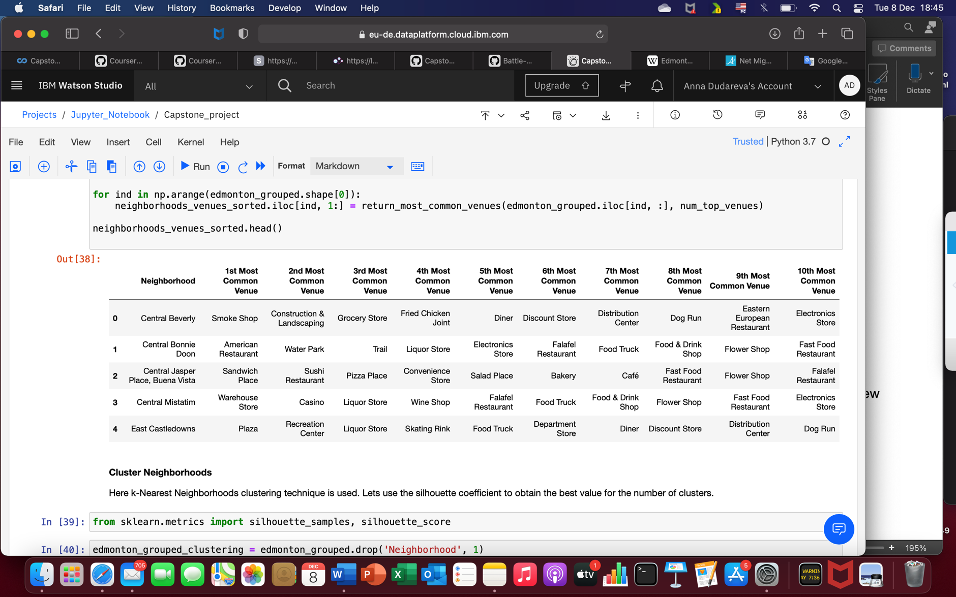

Image 4. Top 10 common venues in each neighborhood

This dataset was used for the clustering algorithm, namely K-Nearest Neighbor (KNN) clustering was used. It is an unsupervised machine learning technique that clusters the given data into K number of clusters. For optimal result I had to select the best value of K. So, the silhouette coefficient was used to find the best value for K. A range of value from 2 to 10 was considered. A range of coefficients is demonstrated in the table below. As we can see, n\_clusters=3 has highest Silhouette Coefficient. This means that 3 should be the optimal number of clusters.

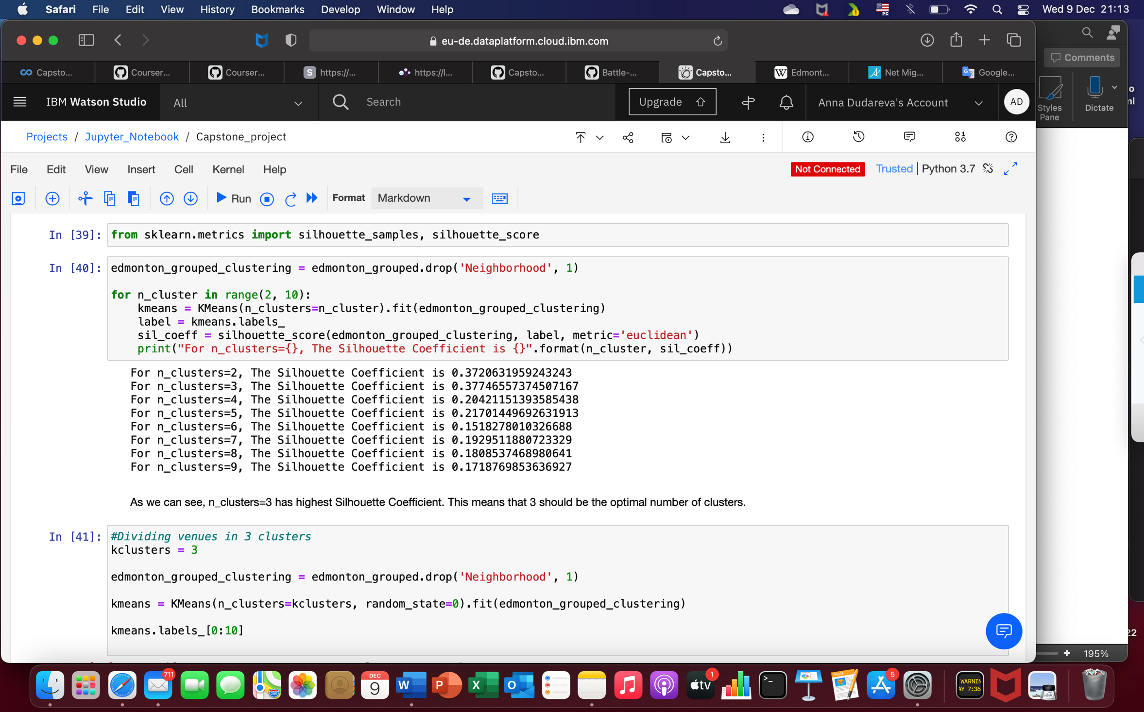

Image 5. The Silhouette Coefficient results

1. **Results**

Let’s examine the three clusters and find the discriminating venue categories that identify each cluster. For this purpose, let’s have a look into 10 most common venue category in each cluster.

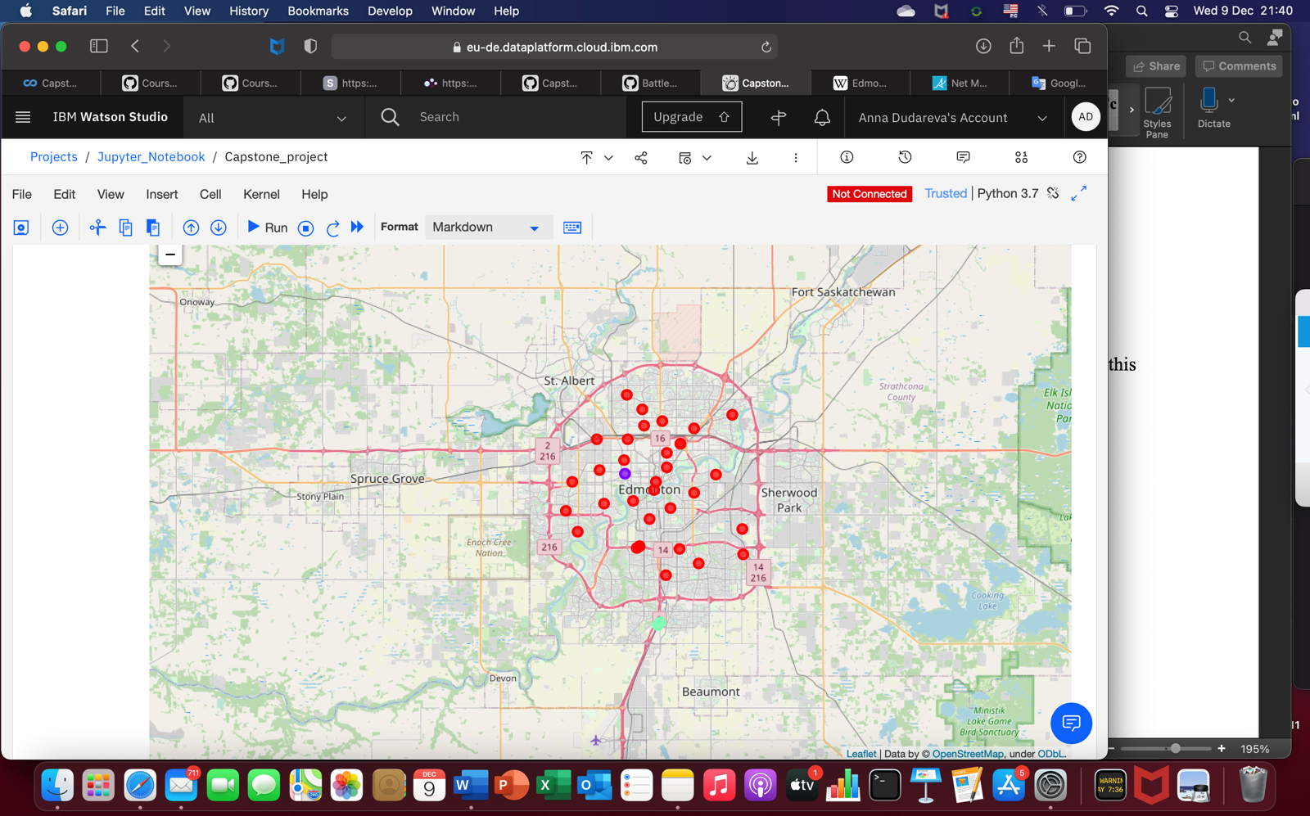

Map 2. Edmonton map with clusters: red-cluster 1, violet-cluster 2, green-cluster 3

**5.1 Cluster 1**

The top venue categories in Cluster 1 are Fast Food Restaurant, Discount Store, Eastern European Restaurant, Distribution Center, Dog Run, Flower Shop, Diner, Electronics Store, Food & Drink Shop, Falafel Restaurant.

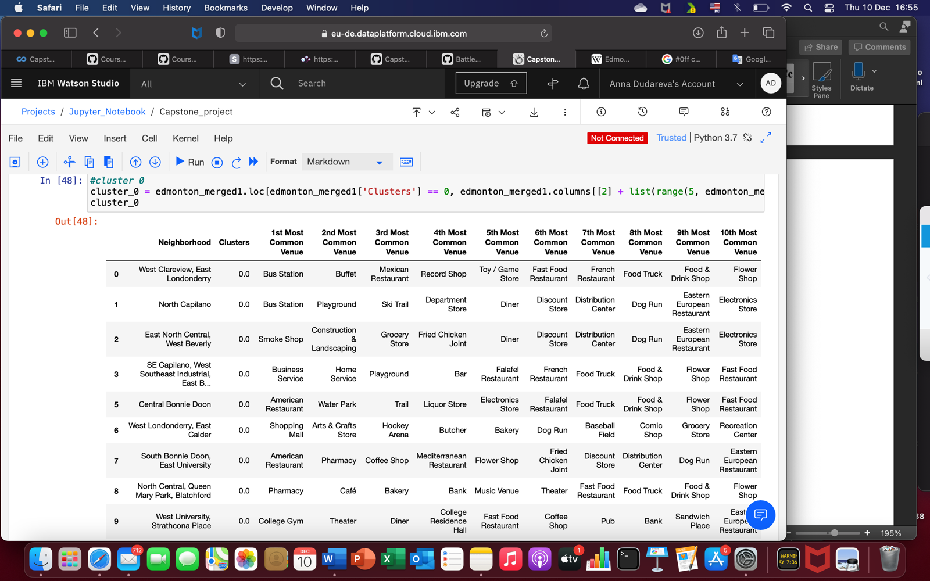

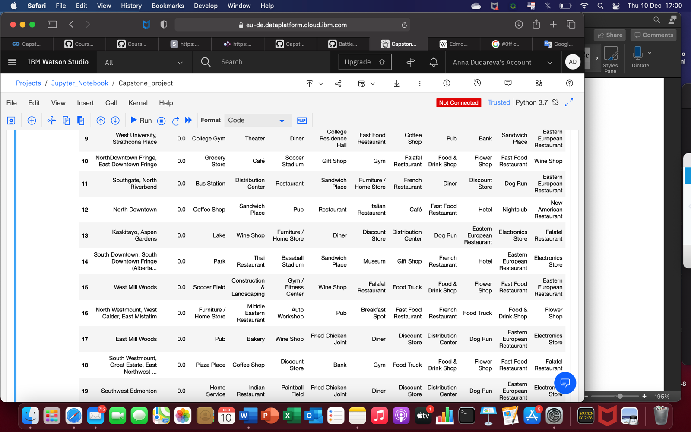

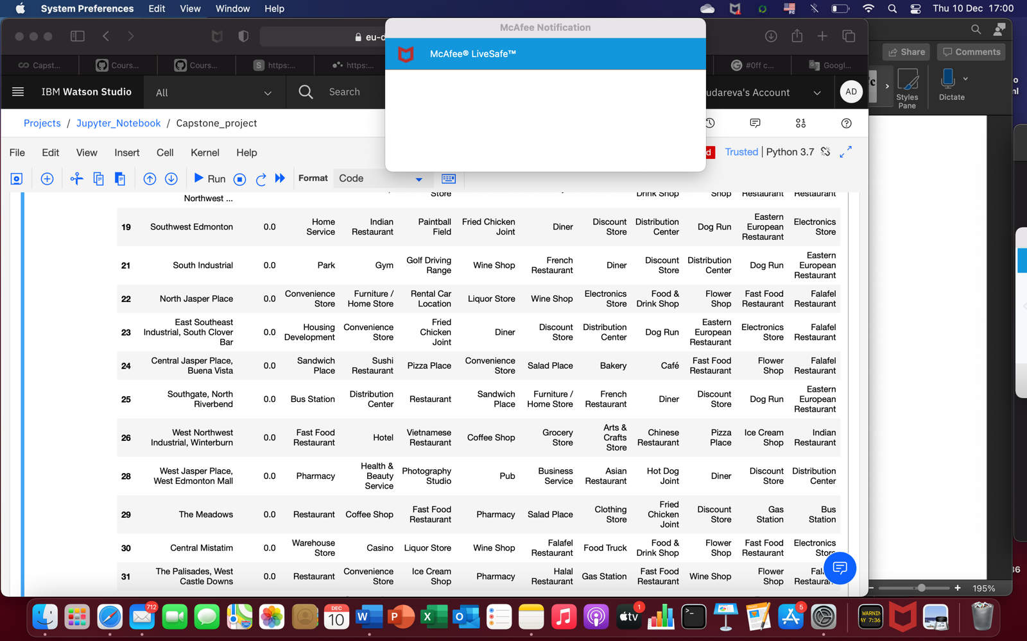

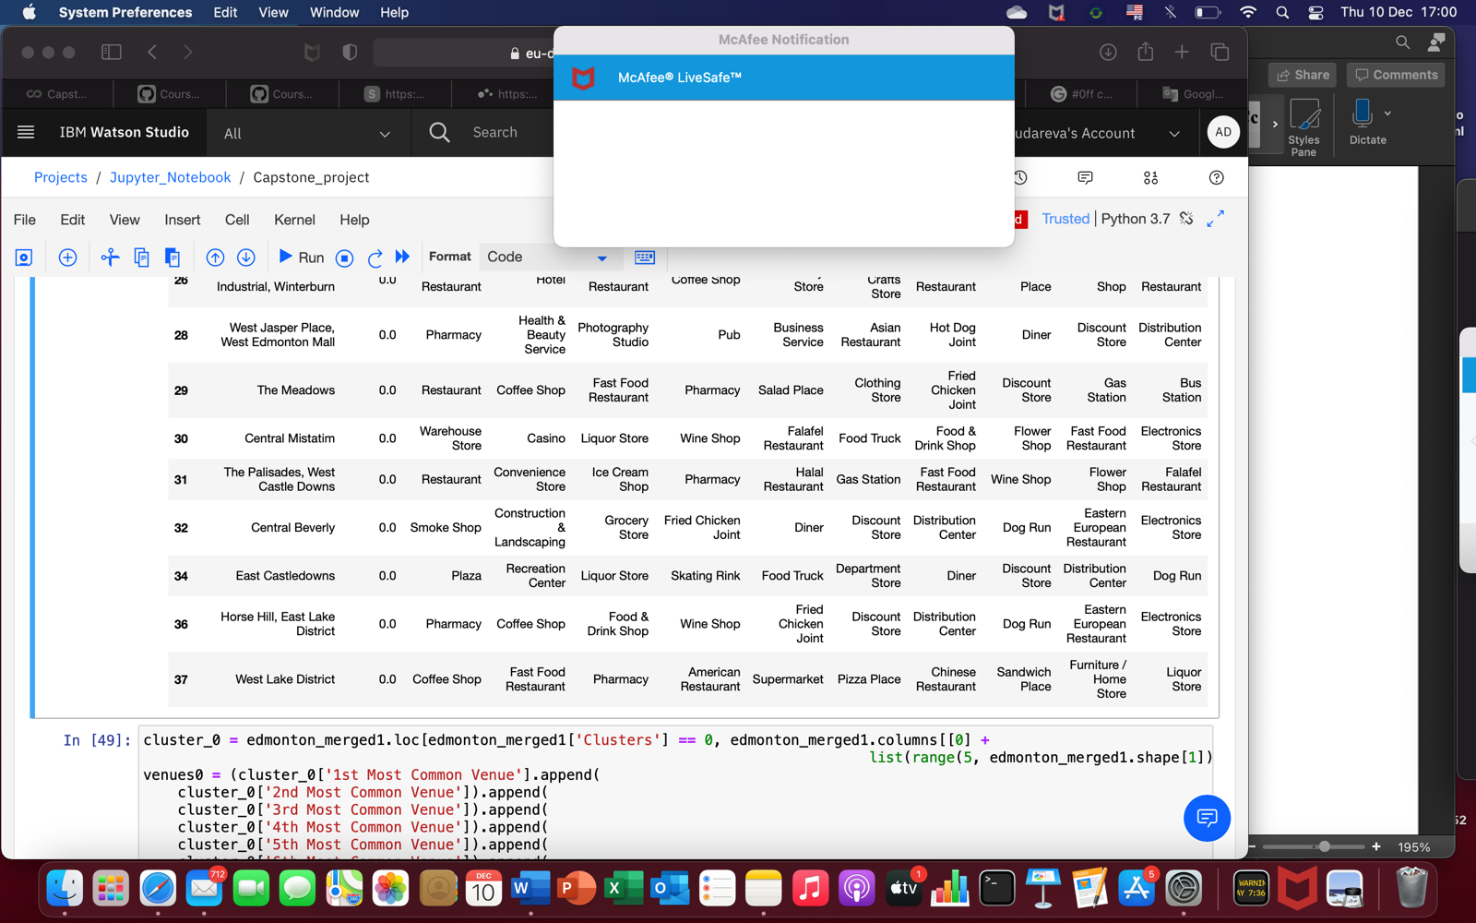

**5.2 Cluster 2**

The top venue categories in Cluster 2 are Portuguese Restaurant, Wine Shop, Fried Chicken Joint, Dinner and Discount Store.

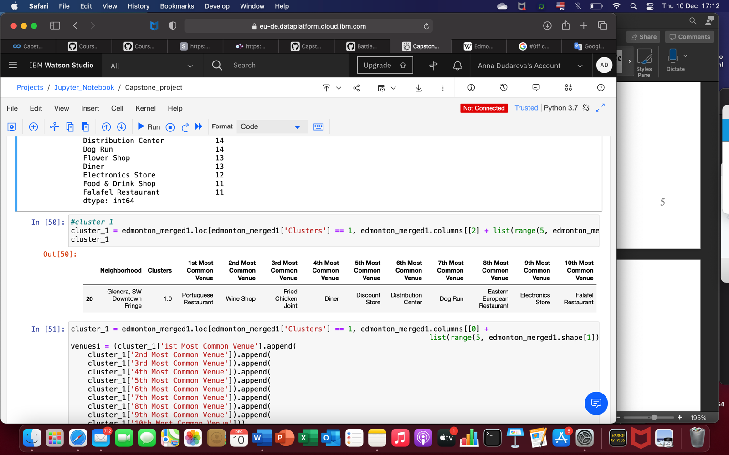

**5.3 Cluster 3**

The top venue categories in Cluster 3 are Gymnastics Gym, Motorcycle Shop, Rest Area, Wine Shop, Home Shop, Fried Chicken Joint, Diner and Discount Store.

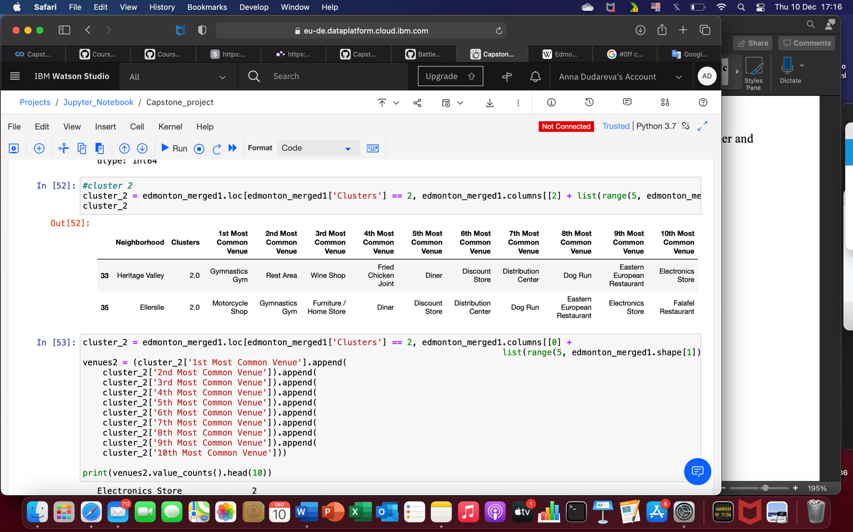

1. **Discussion and future directions**

Now that we have the clusters and the top 10 most common venue categories, let’s visulaize them in each cluster for comparison.

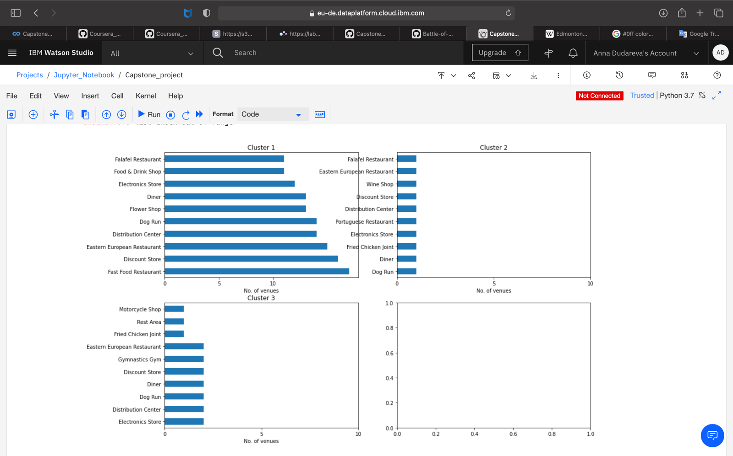

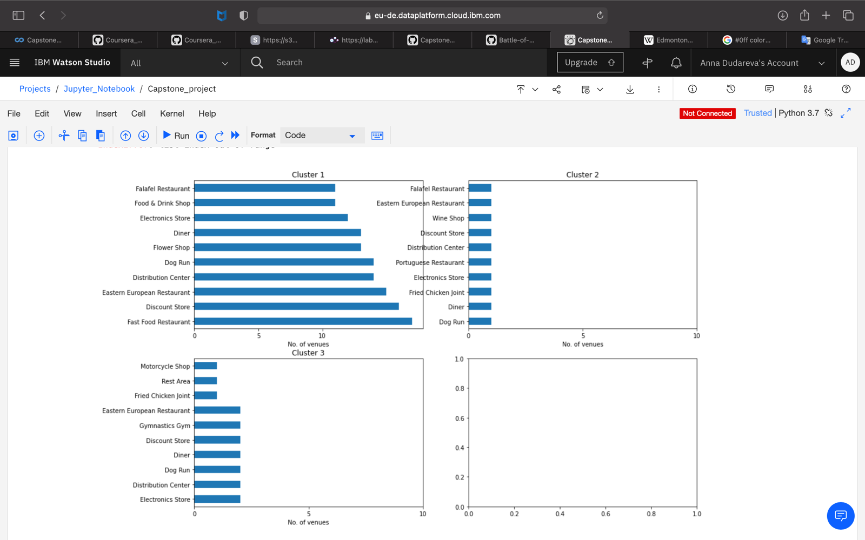

This plot can be used to suggest valuable information to Business persons. Let's discuss a few examples considering they would like to start the following category of business:

* The cluster 1 is situated within the central part of the city, and is saturated with fast food restaurants and some other type restaurants, hence opening one here is not the best choice. I could suggest that this cluster don't need more restaurants, but hotel/hostel, health & beauty shop, or bakery could be a good idea for business.
* On the cotrary, cluster 3 is situated outside the central part of the city, and has one fast food restaurant. Suggestion could be a coffee shop or one more, but another type fast food restaurant. If a deeper analysis could be done, due to location a major project could be suggested, as large shopping mall, indoor climbing park or amusement park for children etc.
* Cluster 2 is the smallest one and is located in central part of the city. The most popular venues there are food and wine, so may be cluster 2 is a good place for a bar, pub or disco.

In this project, I focus on the most common venues in the neighborhoods as well as the frequency of occurrence of different venues. In order to make an insightful data-driven business decision, there are other factors for consideration such as population in each neighborhood and income of residences, the concentration of commercial buildings that could influence the location decision.

Future research could devise a methodology to estimate mentioned above data to be used in the clustering algorithm to identify the prime locations for a new business. This project uses a free developer account of Foursquare API that came with limitations on how many API calls and results returned. Future research could use a paid account to bypass these limitations for better results.

1. **Conclusion**

This section concludes the predictive analysis for finding suitable location to open a new business in Edmonton. I have used different python packages to extract, scrap the necessary data from Wikipedia and to visualise data, also Foursquare API was used to explore the venues in neighborhoods. Final section of the project was to group venues in clusters and define the characteristics for that particular cluster. I have found three clusters, to of which are situated in the central part of the Edmonton, however the third cluster is located outside. A few examples for the applications that the clusters can be used for have also been discussed. A map showing the clusters have been provided. So all this information can be used by stakeholders to decide the location for the particular type of business.